**1 a)** What are the main differences between a eukaryotic and a prokaryotic cell? (2)

**b)** Prokaryotic cells are thought to have evolved before eukaryotes. What evidence do scientists have for this? (1)

**c)** The table below shows the differences between eukaryotes and prokaryotes. Put a tick if an organelle is present and a cross if it is absent.

|  |  |  |
| --- | --- | --- |
| Structure | Eukaryote | Prokaryote |
| Mitochondria |  |  |
| Ribosomes |  |  |
| Cytoplasm |  |  |
| Plasmid |  |  |

(4)

**d)** Some eukaryotic organelles are found in animals only, some in plants only and some in both. Complete the Venn diagram by putting the organelles into the correct sections.

chloroplasts cell membrane vacuole

nucleus                  cell wall                 starch grains

chromosomes mitochondria glycogen           (9)

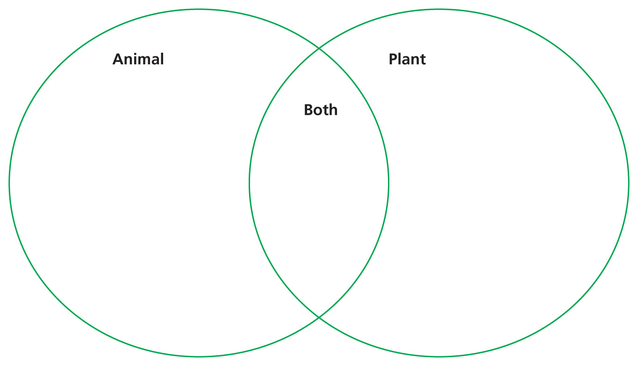

**e)** What is the job of:

**i)** the cell surface membrane?

**ii)** ribosomes? (2)

**2** Look at the sperm cell in the diagram.

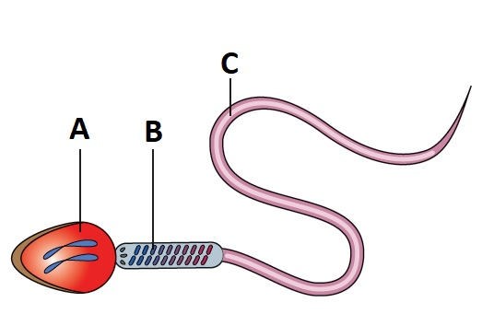

**a)** Label parts A, B and C on the diagram. (3)

**b)** What is the role of a sperm cell? (1)

**c)** How do the organelles found in part B help the sperm cell to swim? (2)

**d)** The sperm cell has been magnified 10 000 times to make it 120 mm long.  
What is 120 mm in µm? (1)

**e)** Calculate the actual size of the sperm cell in:

**i)** mm (1)

**ii)** µm. (1)

(Show your working out.)

**3** Plants and animal cells that carry out a particular job are described as specialised. These cells have changed or differentiated in some way. Xylem and phloem are specialised plant cells. They are found together in bundles. These bundles can be seen in the veins of leaves. Xylem and phloem are part of the plant’s transport system.

**a)** What materials are carried in the:

**i)** xylem (1)

**ii)** phloem (1)

**b)** Describe three features of the xylem tissue which helps it carry out its role in a plant? (3)

**c)** What is translocation? (2)

**4** Microscopes make it possible to see very small objects in much greater detail. The microscope does this by enlarging the object so that it looks bigger. They also allow two objects which are very close together to be seen as separate structures.

**a)** Copy out the section of the paragraph which is a description of resolution. (1)

**b)** Copy out the section of the paragraph which describes magnification. (1)

**c)** A specimen is put under a light microscope which has a ×20 magnification eyepiece lens and ×40 magnification objective lens. What is the total magnification of the specimen? Show your working out. (2)

**d)** The picture below was taken with a microscope.

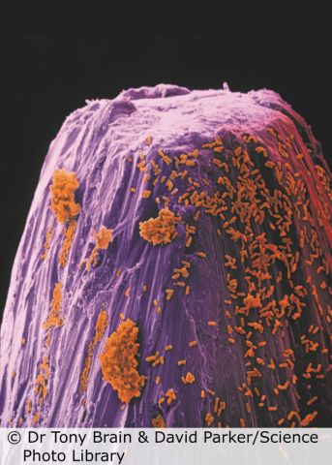

What type of microscope was used to take these pictures? Explain your answer. (2)

**e)** List two ways in which the electron microscope differs from the light microscope. (4)

**f)** The following are some precautions that need to be taken when making a microscope slide. Explain why each is important.

**i)** The section must be very thin.

**ii)** The specimen must be stained.

**iii)** A cover slip should be placed on top. (3)

TOTAL = 50

**1 a)** Eukaryotes have a nucleus; eukaryotes are much larger. (2)

**b)** Prokaryotes do not have as many organelles as eukaryotes so are much simpler. (1)

**c)**

|  |  |  |
| --- | --- | --- |
| Structure | Eukaryote | Prokaryote |
| Mitochondria | $$√$$ | x |
| Ribosomes | $$√$$ | $$√$$ |
| Cytoplasm | $$√$$ | $$√$$ |
| Plasmid | x | $$√$$ |

1 mark for each correct line (4)

**d)**

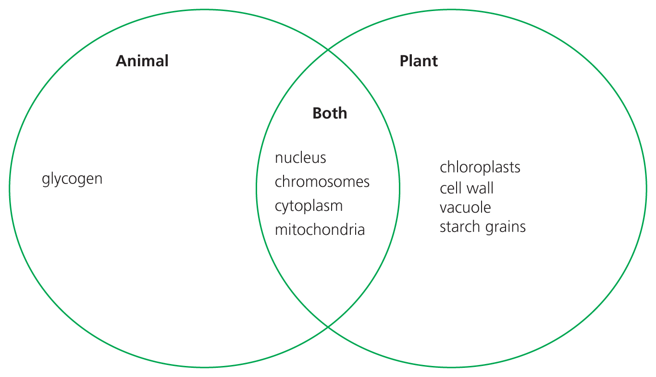 (9)

**e)** **i)** Controls the entry of substances into and out of the cell.

**ii)** Synthesis of proteins (2)

**2** **a)** A = nucleus; B = mitochondria; C = tail (3)

**b)** Delivers the male nucleus to the female egg cell/fertilization (1)

**c)** Mitochondria release energy from glucose. The energy is used to move the tail. (2)

**d)** 120 mm = 120,000 µm (1)

**e)** Actual size of the sperm cell = image size/magnification

**i)** 120/10 000 = 0.012 mm (1)

**ii)** 0.012 × 1000 = 12 µm (1)

**3 a)** **i)** Xylem carries water and dissolved mineral ions. (1)

**ii)** Phloem carries sugars (sucrose) and products of photosynthesis. (1)

**b)** Xylem cells are dead and woody. They have no living contents. They are hollow tubes. (3)

**c)** Translocation is the movement of sugar in the phloem. It is an active process.  
It requires energy. (2)

**4 a)** They also allow two objects which are very close together to be seen as  
separate structures. (1)

**b)** The microscope does this by enlarging the object so that it looks bigger. (1)

**c)** Total magnification of the specimen = 20 × 40 = 800 (2)

**d)** The pictures below were taken with an electron microscope. They show up the minute detail of internal structures. (2)

**e)** Light microscope uses glass lenses. Electron microscope uses beam of electrons.

Light microscope uses dyes/stains. Electron microsope uses heavy metals.

Light microscope image seen through eyepiece lens. Electron microscope image seen on the screen.

(Two marks per comparative response) (4)

**f)** **i)** Light can pass through into the lenses.

**ii)** The structures inside the cell show up/gives contrast.

**iii)** The cover slip protects the lens/stops the specimen drying out/ holds the specimen in position. (3)

TOTAL = 47